Final Project: Proposal/Dataset Selection   
Morgyn Joubert, Sean McLean  
College of Professional Studies, Northeastern University   
ALY6015: Intermediate Analytics  
Prof. Thomas Goulding  
February 9, 2024

INTRODUCTION

The entertainment industry, particularly the movie sector, is characterized by the considerable financial investments and uncertainties over return on those investments. This preliminary analysis looks first at the dataset of movies to understand the relationship between the budgets and revenue. The other portion of the analysis focuses on potential correlations between movie features and its user interactions. Utilizing statistical techniques such as descriptive statistics, correlation analysis and regression modeling, we hope to derive the fundamental aspects of what makes a successful movie.

DATASET OVERVIEW

Initial exploration of the dataset revealed a dataset with a variety of movie budgets, popularity, revenue, and other characteristics. The summary statistics provided insight that the budget and revenues of movies range widely and as a result there will be that much variability within our dataset. For instance, the median budget was at $15 million, and the median revenue was approximately at $19.17 million. User responses to the movies in the data set also show large ranges in variables like popularity scores and total vote counts per movie. This sort of variability underscores the need for further analysis to understand the key drivers of movie success.

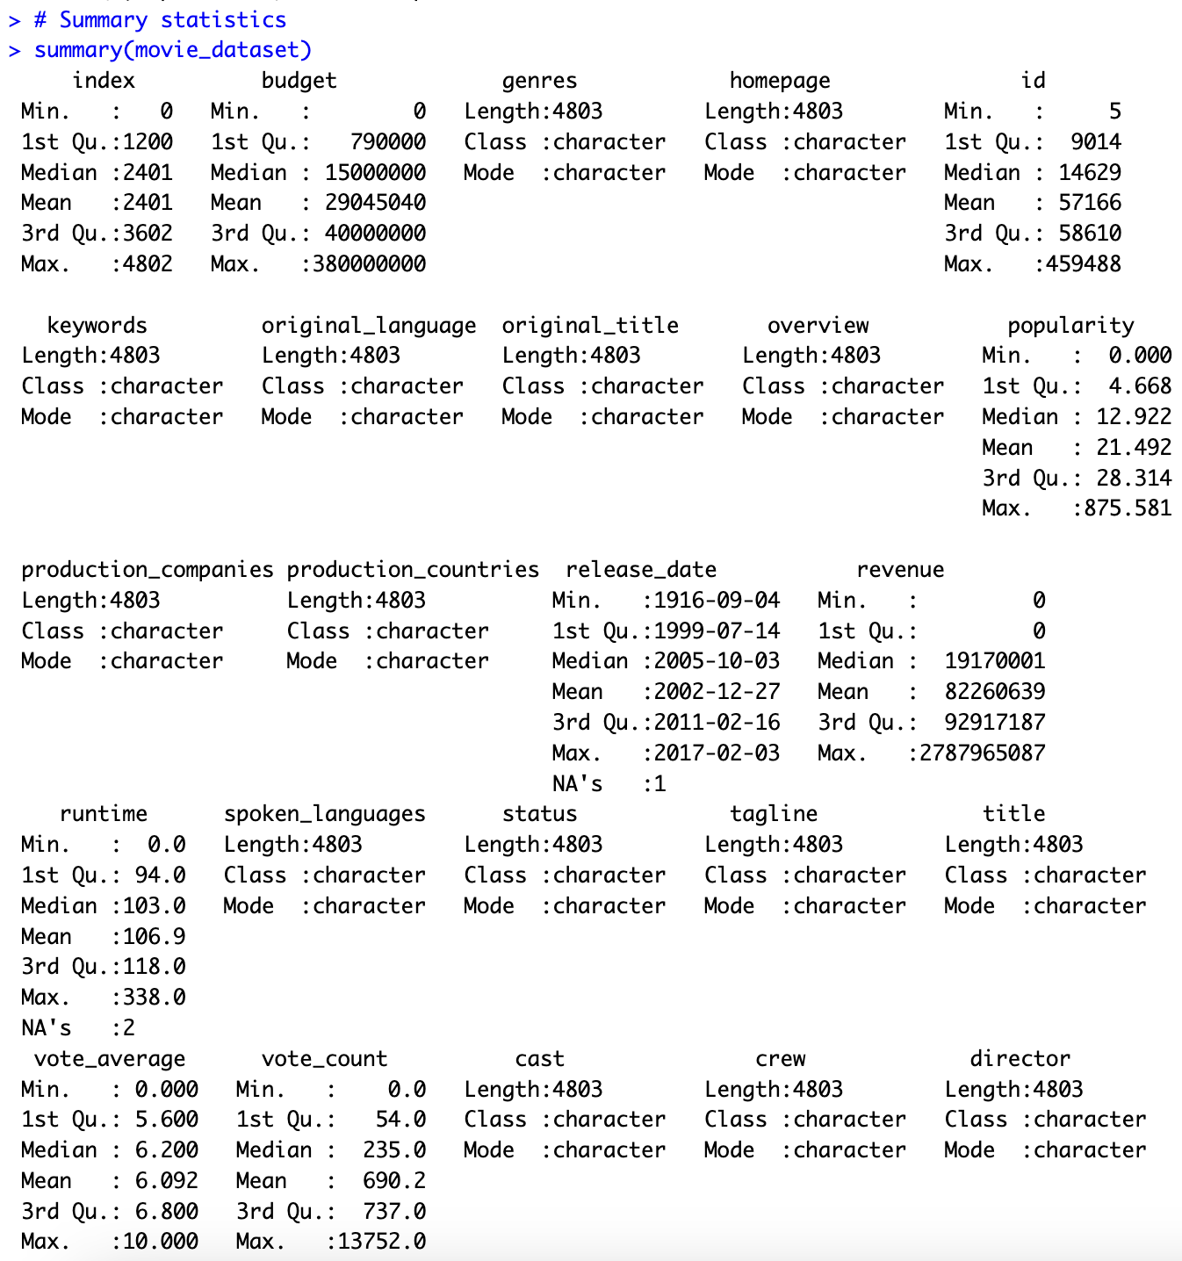

The summary statistics for the other question being studied had one small modification to allow for proper modeling. The variable ‘runtime’ had two observations with missing values, so these were removed for the subsequent heatmap to be executed.

PRELIMINARY ANALYSIS

We started our preliminary analysis of the relationship between movie budget and revenue by examining the Pearson correlation coefficient. Visualization, through histograms and scatter plots, to understand the distribution and relationship between budgets and revenues, helped us get a feel for the data.

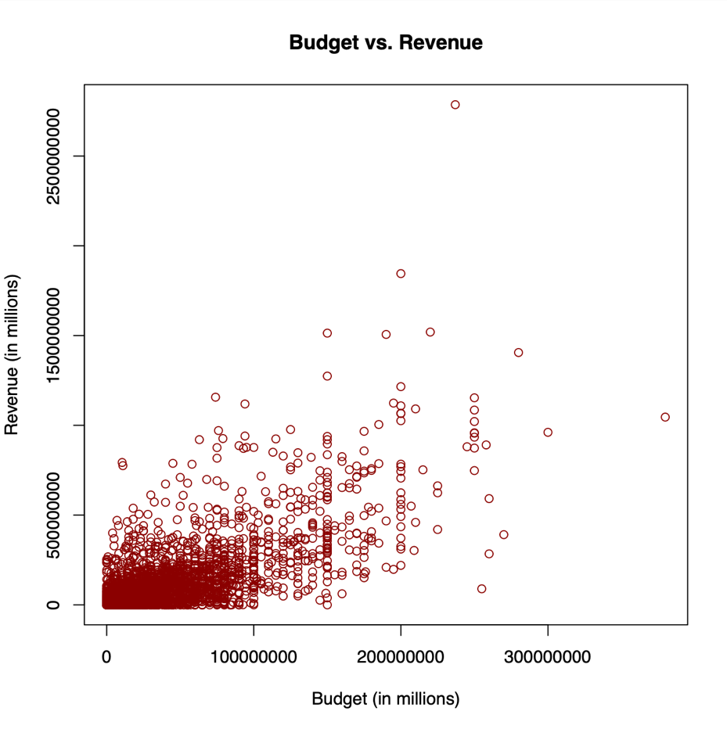

A linear regression model was fitted to assess the relationship between budget and revenue. The regression analysis indicated a statistically significant positive association between the two variables. The positive correlation between budget and revenue indicates that higher investments in production typically result in higher returns. For each additional unit of currency spent on the budget, revenue increased by approximately 2.9227 units of currency.

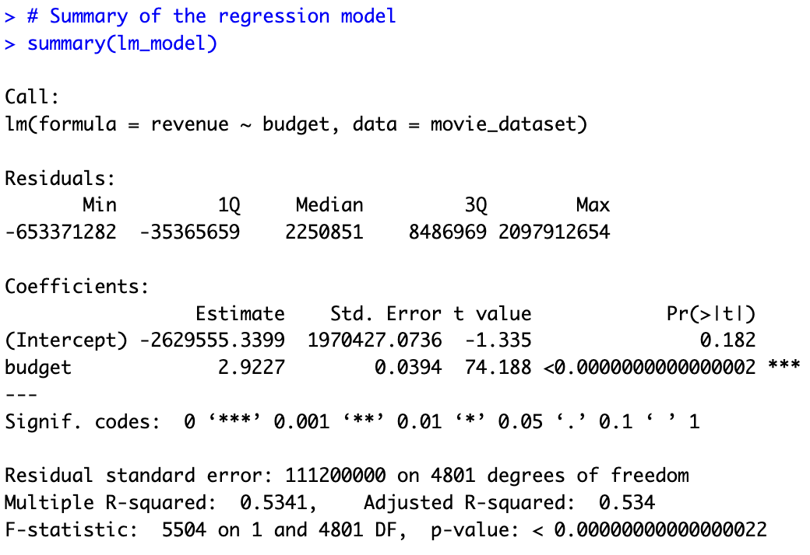

It is important to note, however, that this study naturally has its limitations, and one of them might be the inclusion of factors such as genre, release date, and marketing strategies which could have a significant influence on a movie's success.

The other question in the final project looked at the correlation between user interactions and movie features in the data set. Six numerical variables were selected for a correlation analysis that pertained to movie characteristics and user actions like voting ratings. A correlation matrix was constructed to identify any positive linear relationships among the chosen variables.

Interpreting the matrix, there are several strong relationships with ‘revenue’, ‘popularity’ and ‘vote_count’ standing out among the variables. The revenue variable has a high association with the ‘vote_count’ and ‘popularity’ variables, suggesting that it affects user responses in some capacity. Another strong relationship among the matrix is the ‘popularity’ and’vote_count’ variables which could indicate that the number of votes for a movie can have an immense effect on its popularity score. The ‘id’ variable could be eliminated from the mix due to having negative or indifferent correlations with all the other variables.

A heatmap is used to visualize correlation matrices and identify trends and patterns in the data. The darker shades of red reflect the strong correlations mentioned in the matrix.

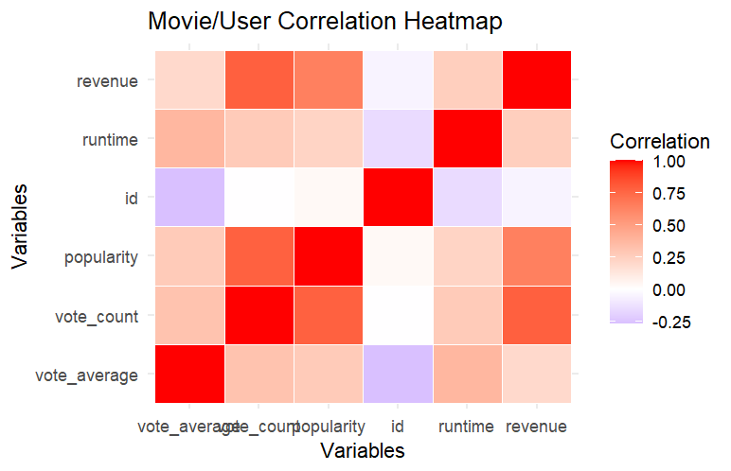 To understand the relationships between two variables with strong positive linear correlations, a pair of scatterplots are built for visual representation of the interactions. To avoid the issue of over dense plotting and cluttering with a large data set, a sample was taken and split into training and testing sets to assess the performance and generalization ability of the model. The 'id’ variable was eliminated from the previous dataset because of its irrelevancy toward the other variables. A linear regression model was then used to analyze the coefficients of each independent variable.

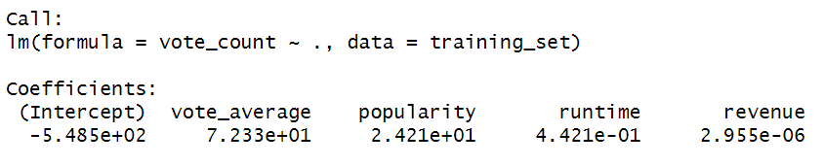

Positive coefficients indicate a positive association, and negative coefficients suggest a negative association, and the magnitude of the coefficients indicates the strength of the effect. All four variables show a positive correlation to the vote counts of the movies in the data set. A k-fold cross validation is then conducted to assess how well the model will popularize to an independent data set.

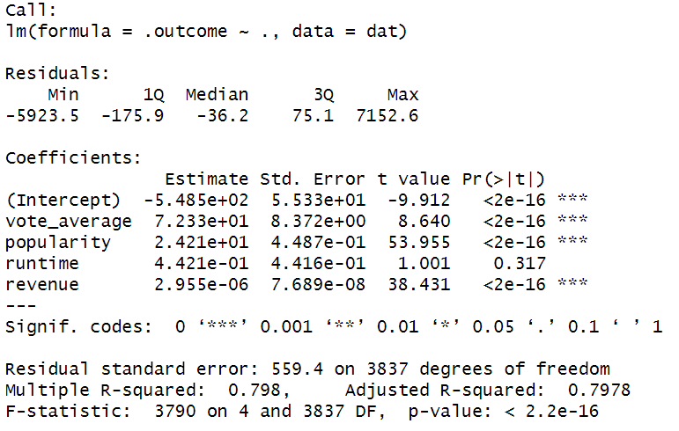

An analysis of the summary shows that the ‘runtime variable’ has a higher p-value (0.317), suggesting that it may not be a statistically significant predictor in the model. The F-statistic that shows the overall significance of the model is large, and the associated p-value is very small (< 2.2e-16), indicating that the overall model is statistically significant. Overall, the model is well-fitted with statistically significant predictors.

The models of the samples conducted are plotted to show the relationships between the response variable ‘vote_count’ and the independent variables ‘revenue’ and ‘popularity’ which showed the strongest correlations in the correlation matrix. Most of the observations in the scatterplot are under 3000 votes and $250 million in revenue. The outliers in the plot are heading in a positive direction, indicating that the higher the revenue for a movie, the higher the vote count for that movie. The analysis of the line plot between the variables ‘vote_counts’ and ‘popularity’ is similar with the popularity score being high when the vote count for the movie is also high. The few outliers in the plot also demonstrate the same patterns.

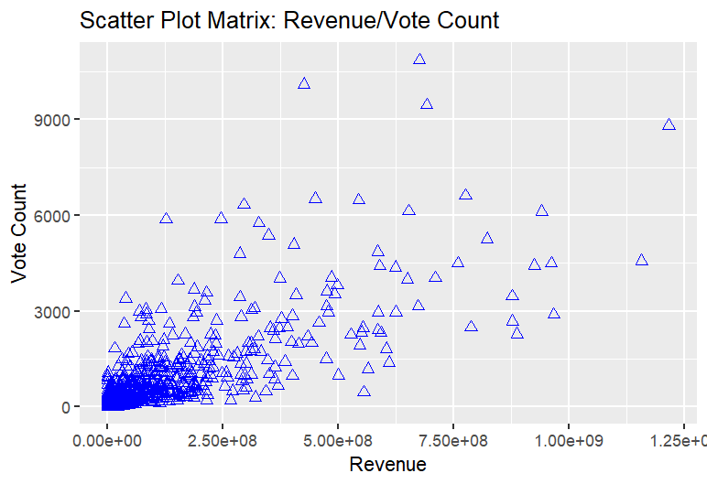

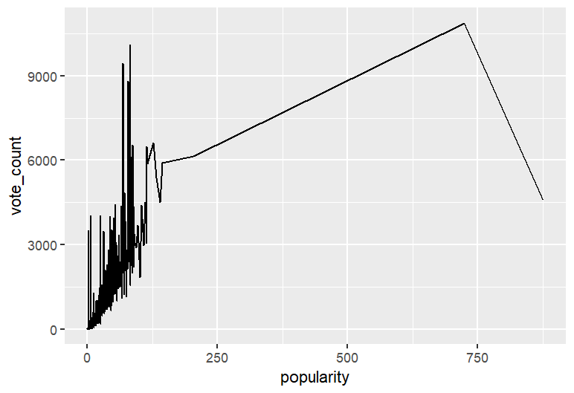

Additional categorical variables that were explored using Analysis of Variance (ANOVA) testing were release dates and whether there were significant differences between them. To again alleviate the concern of over dense plotting and cluttering with the data set, a sample was taken and split into training and testing sets to assess the performance and generalization ability of the model.

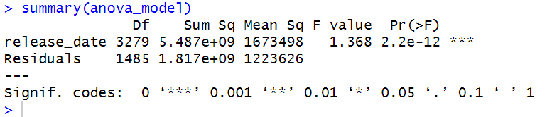

Examining the ANOVA model, the p-value is very small (2.2e-12), suggesting that there is a significant association between ‘release_date’ and the response variable. The table also suggests that the variable ‘release_date’ is statistically significant in explaining the variability in the voting count totals. The line plot is created to show this relationship and the analysis shows that movies released more recently have slightly higher voting counts than older movies. The top movies by vote count are all more recent, but because of the plot not showing a strong association might mean this will need to be evaluated more to see if this relationship is strong despite the low p-value in the ANOVA model.

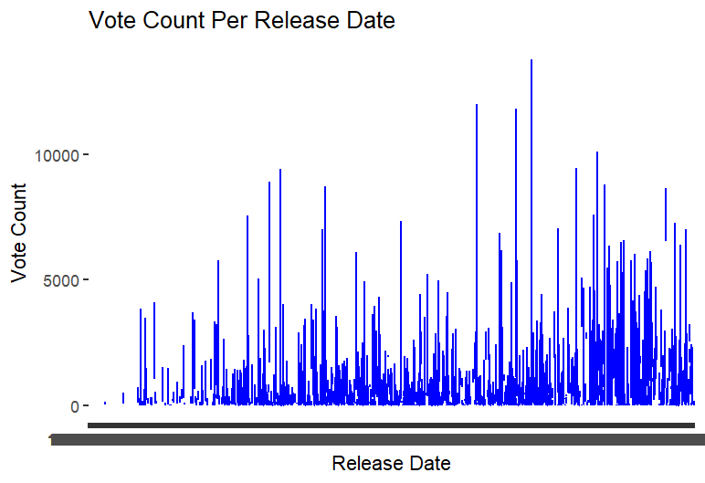

For the final submission, we will expand our investigation by including additional variables, such as genre, release date, and marketing expenditure. These will enable us to build out our regression model and account more fully for multiple factors that influence a movie's revenue. Furthermore, an in-depth analysis would include the chi-square test, ANOVA, and other advanced statistical methodologies, which will allow us to gain insights into relationships present within the dataset.

CONCLUSION

Our preliminary analysis from the first question indicates that budget plays a significant role in determining movie revenue. While it’s true that higher investments are generally aimed at higher returns, there are several other success factors for filmmakers and industry stakeholders to consider. The correlations involving movie and user relationships show mainly positive associations, with certain aspects of movies like revenue and vote counts having an impact on its popularity and vote average. By conducting further analysis and utilizing more advanced statistical techniques, we can identify actionable insights that can help decision-making in the dynamic and hyper-competitive movie business.

REFERENCES

Bluman, A. (2018). Elementary statistics: A step by step approach (10th ed.). McGraw Hill.

Kabacoff, R. I. (2022). R in action: Data analysis and graphics with R and tidyverse (3rd ed.).

Manning Publications.

Northeastern University – Canvas – (Panopto) videos by Prof. Thomas Goulding

APPENDIX

#Question 1: Correlation between Movie Budget and Popularity

# Load necessary libraries

library(readr)

library(ggplot2)

# Load the dataset

movie_dataset <- read_csv("/Users/m.joubert/Documents/Final Project: Initial Analysis Report - Joubert/movie_dataset.csv")

# Explore the structure of the dataset

str(movie_dataset)

#Summary statistics

summary(movie_dataset)

# Histogram of budget

hist(movie_dataset$budget, breaks = 20, col = "skyblue", main = "Distribution of Budget", xlab = "Budget (in millions)")

# Scatter plot of budget vs. revenue

plot(movie_dataset$budget, movie_dataset$revenue,

main = "Budget vs. Revenue",

xlab = "Budget (in millions)",

ylab = "Revenue (in millions)",

col = "darkred")

# Fit linear regression model

lm_model <- lm(revenue ~ budget, data = movie_dataset)

# Summary of the regression model

summary(lm_model)

#Question: Correlation between user interactions and movie features

#Loading necessary libraries

library(readr)

library(dplyr)

library(ggplot2)

library(caret)

#Importing the dataset

movie_dataset <- read.csv("movie_dataset.csv", header = TRUE)

movie_dataset

#Summary statistics of the dataset

summary(movie_dataset)

View(movie_dataset)

#Remove all observations with 'NA' in the 'runtime' variable

dataset <- movie_dataset[complete.cases(movie_dataset$runtime), ]

#Display the modified dataset

summary(dataset)

#Perform correlation analysis

correlation_matrix <- cor(dataset[c("vote_average", "vote_count", "popularity", "id", "runtime", "revenue")])

correlation_matrix

# Reshape the correlation matrix to long format for heatmap

library(tidyr)

cor_long <- as.data.frame(as.table(correlation_matrix))

names(cor_long) <- c("Var1", "Var2", "Correlation")

# Create a heatmap using ggplot2

heatmap_plot <- ggplot(data = cor_long, aes(x = Var1, y = Var2)) +

geom_tile(aes(fill = Correlation), color = "white") +

scale_fill_gradient2(low = "blue", high = "red", mid = "white", midpoint = 0) + # Adjust color scale

labs(title = "Movie/User Correlation Heatmap",

x = "Variables",

y = "Variables") +

theme_minimal()

print(heatmap_plot)

#Create a new variable from dataset for sampling

movies <- dataset %>%

select(vote_average, vote_count, popularity, runtime, revenue)

summary(movies)

# Split the dataset into training and testing sets

set.seed(456)

trainIndex <- createDataPartition(movies$vote_count, p = 0.8, list = FALSE)

training_set <- movies[trainIndex, ]

testing_set <- movies[-trainIndex, ]

# Create a linear regression model

model <- lm(vote_count ~ ., data = training_set)

model

# Make predictions on the test set

predictions <- predict(model, newdata = testing_set)

# Evaluate the model

rmse <- sqrt(mean((predictions - testing_set[["vote_count"]])^2))

print(paste("Root Mean Squared Error:", rmse))

# Perform k-fold cross-validation

ctrl <- trainControl(method = "cv", number = 10)

cv_model <- train(vote_count ~ ., data = training_set, method = "lm", trControl = ctrl)

# Print cross-validation results

print(cv_model)

# Access the mean performance metrics across folds

summary(cv_model)

#Individual Scatter Plots Showing Relationship Between Vote Count and Revenue.

scatter_plot_matrix <- ggplot(testing_set, aes(x = revenue, y = vote_count)) +

geom_point(shape = 2, color = "blue", size = 2) +

labs(title = "Scatter Plot Matrix: Revenue/Vote Count",

x = "Revenue",

y = "Vote Count")

scatter_plot_matrix

#Individual Line Plots Showing Relationship Between Vote Count and Popularity.

ggplot(testing_set, aes(x = popularity, y = vote_count)) +

geom_line()

#Perform ANOVA testing

#Create a new variable from dataset for testing

anovas <- dataset %>%

select(vote_count, release_date)

summary(anovas)

#Split dataset into a training set and a test set.

set.seed(123)

index <- createDataPartition(anovas$release_date, p = 0.8, list = FALSE)

train_data <- anovas[index, ]

test_data <- anovas[-index, ]

#Create ANOVA model

anova_model <- aov(vote_count ~ release_date, data = train_data)

summary(anova_model)

#Conduct post-hoc tests

TukeyHSD(anova_model)

#Lineplot for one-way ANOVA

ggplot(train_data, aes(x = release_date, y = vote_count)) +

geom_line(color = "blue") +

labs(title = "Vote Count Per Release Date",

x = "Release Date",

y = "Vote Count")